PROJECT INFO
Project title | Soil Erosion and Torrential Flood Prevention: Curriculum Development at the Universities of Western Balkan Countries
Project acronym | SETOF
Project reference number | 598403-EPP-1-2018-1-RS-EPPKA2-CBHE-JP  (2018-2579/001-001)
Coordinator | University of Belgrade
Project start date | November 15, 2018
Project duration | 36 months

DOCUMENT CONTROL SHEET
Ref. No and Title of Activity | WP5 Dissemination & Exploitation
Title of Deliverable | Minutes of the Introduce and training teaching staff
Institutions | University of Novi Sad
Author/s of the deliverable | Atila Bezdan, Milica Vranešević, Dragana Krajinović
Status of the document | final

Summary
This document reports the Minutes of the Introduce and training teaching staff within a SETOF project of the Erasmus+ Capacity Building in the Field of Higher Education project “Soil Erosion and Torrential Flood Prevention: Curriculum Development at the Universities of Western Balkan Countries” (SETOF) held in Novi Sad, Serbia on November 12th, 2021.

List of attendees
Fourteen participants from 3 institutions participated at the Minutes of the Introduce and training teaching staff. The list of attendees is present below.
No. | Name of the participant | Institution/Organization
1. | Paolo Porto | Mediterranean University of Reggio Calabria
2. | Bezdan Atila | University of Novi Sad, Faculty of Agriculture
3. | Vranešević Milica | University of Novi Sad, Faculty of Agriculture
4. | Savić Radovan | University of Novi Sad, Faculty of Agriculture
5. | Blagojević Boško | University of Novi Sad, Faculty of Agriculture
6. | Stajić Milica | University of Novi Sad, Faculty of Agriculture
7. | Antić Sanja | University of Novi Sad, Faculty of Agriculture
8. | Zemunac Radoš | University of Novi Sad, Faculty of Agriculture
9. | Salvai Andrea | University of Novi Sad, Faculty of Agriculture
10. | Dragović Nada | University of Belgrade, Faculty of Forestry
11. | Katarina Lazarević | University of Belgrade, Faculty of Forestry
12. | Vulević Tijana | University of Belgrade, Faculty of Forestry
13. | Baumgertel Aleksandar | University of Belgrade, Faculty of Forestry
14. | Polovina Siniša | University of Belgrade, Faculty of Forestry

Prof. dr Atila Bezdan opened the meeting and welcome participants. The Training covered several topics in framework of Soil Erosion and Torrential Flood Prevention at the Mediterranean University of Reggio Calabria (WP2 Development of curricula, Activity 2.7. Introduce and training teaching staff). Prof. dr Paolo Porto gave some inside into soil erosion and torrential floods problem and prevention in Reggio Calabria, Italy. The member of the SETOF project and training participants discussed the previous works on erosion and torrential flood prevention, good and bad examples of the constructed objects.

Conclusions
The conclusion is that Introduce and training teaching staff were successfully realized. All material from the meeting will be sent to the project participants.
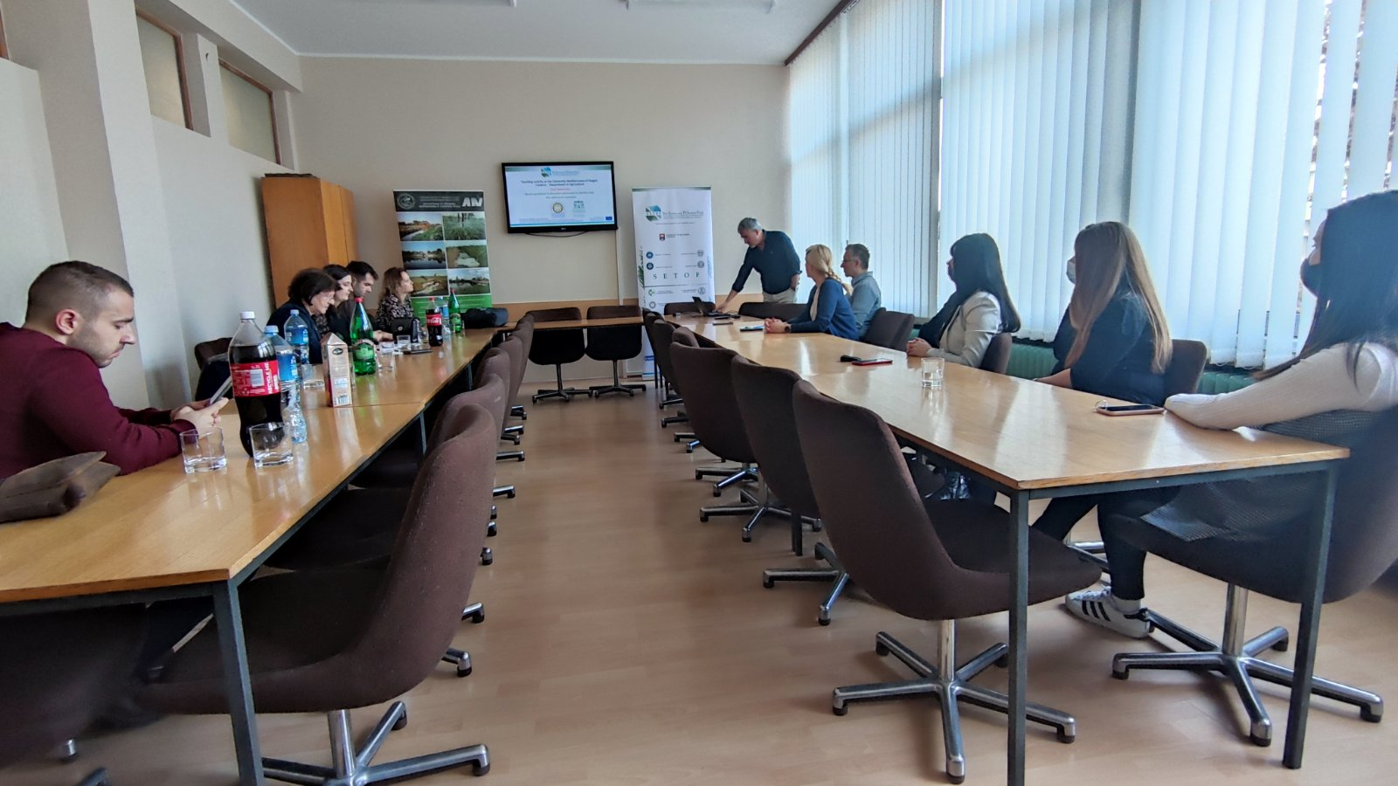

Project number: 598403-EPP-1-2018-1-RS-EPPKA2-CBHE-JP “This project has been funded with support from the European Commission. This publication reflects the view only of the author, and the Commission cannot be held responsible for any use which may be made of the information contained therein”.

In Novi Sad, 18th November 2021

