PROJECT INFO
Project title | Soil Erosion and Torrential Flood Prevention: Curriculum Development at the Universities of Western Balkan Countries
Project acronym | SETOF
Project reference number | 598403-EPP-1-2018-1-RS-EPPKA2-CBHE-JP  (2018-2579/001-001)
Coordinator | University of Belgrade
Project start date | November 15, 2018
Project duration | 36 months

DOCUMENT CONTROL SHEET
Ref. No and Title of Activity | WP5 Dissemination & Exploitation
Title of Deliverable | Minutes of the Introduce and training teaching staff
Institutions | University of Niš
Author/s of the deliverable | Atila Bezdan, Milica Vranešević, Dragana Krajinović
Status of the document | final

Summary
This document reports the Minutes of the Introduce and training teaching staff within a SETOF project of the Erasmus+ Capacity Building in the Field of Higher Education project “Soil Erosion and Torrential Flood Prevention: Curriculum Development at the Universities of Western Balkan Countries” (SETOF) held in Niš, Serbia on November 10th, 2021.

List of attendees
Twenty participants from 3 institutions participated at the Minutes of the Introduce and training teaching staff. The list of attendees is present below.
No. | Name of the participant | Institution/Organization
1. | Paolo Porto | Mediterranean University of Reggio Calabria
2. | Slobodan Milutinović | University of Niš, Faculty of Occupational Safety
3. | Snežana Živković | University of Niš, Faculty of Occupational Safety
4. | Tamara Rađenović | University of Niš, Faculty of Occupational Safety
5. | Goran Janačković | University of Niš, Faculty of Occupational Safety
6. | Dejan Vasović | University of Niš, Faculty of Occupational Safety
7. | Ana Stojanović | University of Niš, Faculty of Occupational Safety
8. | Mladena Lukić | University of Niš, Faculty of Occupational Safety
9. | Danijela Avramović | University of Niš, Faculty of Occupational Safety
10. | Milica Nikodijević | University of Niš, Faculty of Occupational Safety
11. | Tatjana Tomović | University of Niš, Faculty of Occupational Safety
12. | Srđan Cvetković | University of Niš, Faculty of Occupational Safety
13. | Milena Stanković | University of Niš, Faculty of Occupational Safety
14. | Milena Medenica | University of Niš, Faculty of Occupational Safety
15. | Milena Jovanović | University of Niš, Faculty of Occupational Safety
16. | Nikola Mišić | University of Niš, Faculty of Occupational Safety
17. | Dario Javor | University of Niš, Faculty of Occupational Safety
18. | Aleksandra Petković | University of Niš, Faculty of Occupational Safety
19. | Srđan Tešović | University of Niš, Faculty of Occupational Safety
20. | Zorana Živković | University of Niš, Faculty of Occupational Safety

Prof. dr Slobodan Milutinović opened the meeting and welcome participants. The Training covered several topics in framework of Soil Erosion and Torrential Flood Prevention at the Mediterranean University of Reggio Calabria (WP2 Development of curricula, Activity 2.7. Introduce and training teaching staff). Prof. dr Paolo Porto gave some inside into soil erosion and torrential floods problem and prevention in Reggio Calabria, Italy. The member of the SETOF project and training participants discussed the previous works on erosion and torrential flood prevention, good and bad examples of the constructed objects.

Conclusions
The conclusion is that Introduce and training teaching staff were successfully realized. All material from the meeting will be sent to the project participants.
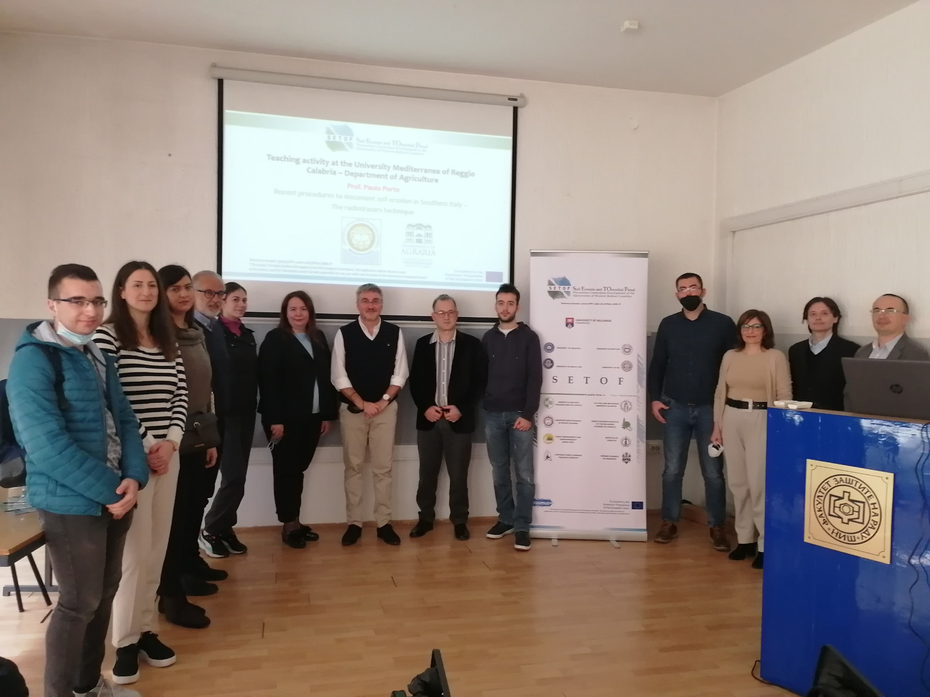

Project number: 598403-EPP-1-2018-1-RS-EPPKA2-CBHE-JP “This project has been funded with support from the European Commission. This publication reflects the view only of the author, and the Commission cannot be held responsible for any use which may be made of the information contained therein”.

In Niš, 12th November 2021

