PROJECT INFO
Project title | Soil Erosion and Torrential Flood Prevention: Curriculum Development at the Universities of Western Balkan Countries
Project acronym | SETOF
Project reference number | 598403-EPP-1-2018-1-RS-EPPKA2-CBHE-JP  (2018-2579/001-001)
Coordinator | University of Belgrade
Project start date | November 15, 2018
Project duration | 36 months

MINUTES

1st Working meeting between Project partner University of Niš and University of Banja Luka, leader of WP3 - Development

DOCUMENT CONTROL SHEET
Ref. No and Title of Activity | WP3 Development
Title of Deliverable | Minutes of the Activity 3.2. New master programme implemented
Institutions | University of Niš, Faculty of Occupational Safety
Author/s of the deliverable | Slobodan Milutinović, Tatjana Golubović, Snežana Živković, Boško Blagojević
Status of the document | Final

Summary
This document represent report the Minutes of the Activity 3.2. New master programme implemented within a SETOF project of the Erasmus+ Capacity Building in the Field of Higher Education project “Soil Erosion and Torrential Flood Prevention: Curriculum Development at the Universities of Western Balkan Countries” (SETOF) held in University of Occupational safety, Niš at the premises of the Faculty on June 02-03 June 2022.

List of attendees
Five participants from 2 institutions participated at the meeting related to Activity 3.2. New master programme implemented in University of Occupational Safety Niš, Serbia. list of attendees is present below.
No. | Name of the participant | Institution/Organization
1. | Slobodan Milutinović | University of Niš, Faculty of Occupational Safety
2. | Tatjana Golubović | University of Niš, Faculty of Occupational Safety
3. | Snežana Živković | University of Niš, Faculty of Occupational Safety
4. | Boško Blagojević | University of Niš, Faculty of Occupational Safety
5. | Marijana Kapović Solomun | University of Banja Luka, Faculty of Forestry

First day the meeting related to the Activity 3.2. teachers discussed possible topics for seminary works of students aiming to address actual issues in the area of soil erosion and torrential floods. After coffee break participants discussed final exams of students how to accomplish all obligations with active inclusions of engaged teachers from both Universities.
Second day of the meeting of the Activity 3.2. there was discussion on joint subjects within master study programme, possible participation of students in FORSD Conference organized by University of Banja Luka in September 2022. Moreover, participants agreed on methodology for master thesis related to filed work. It was highlighted importance of integrative approach in this regard, where different topics can be connected later and used for joint scientific papers. Present teachers were consulted on possible cooperation on different ideas for the master theses.

Conclusions
The conclusion is that the meeting of the Activity 3.2. held in University of Occupational Safety Niš, Serbia was successfully realized. All ideas about futures activities that participants discussed will be implemented in future work on the subjects, student’s final exams and future work on the student’s master theses.
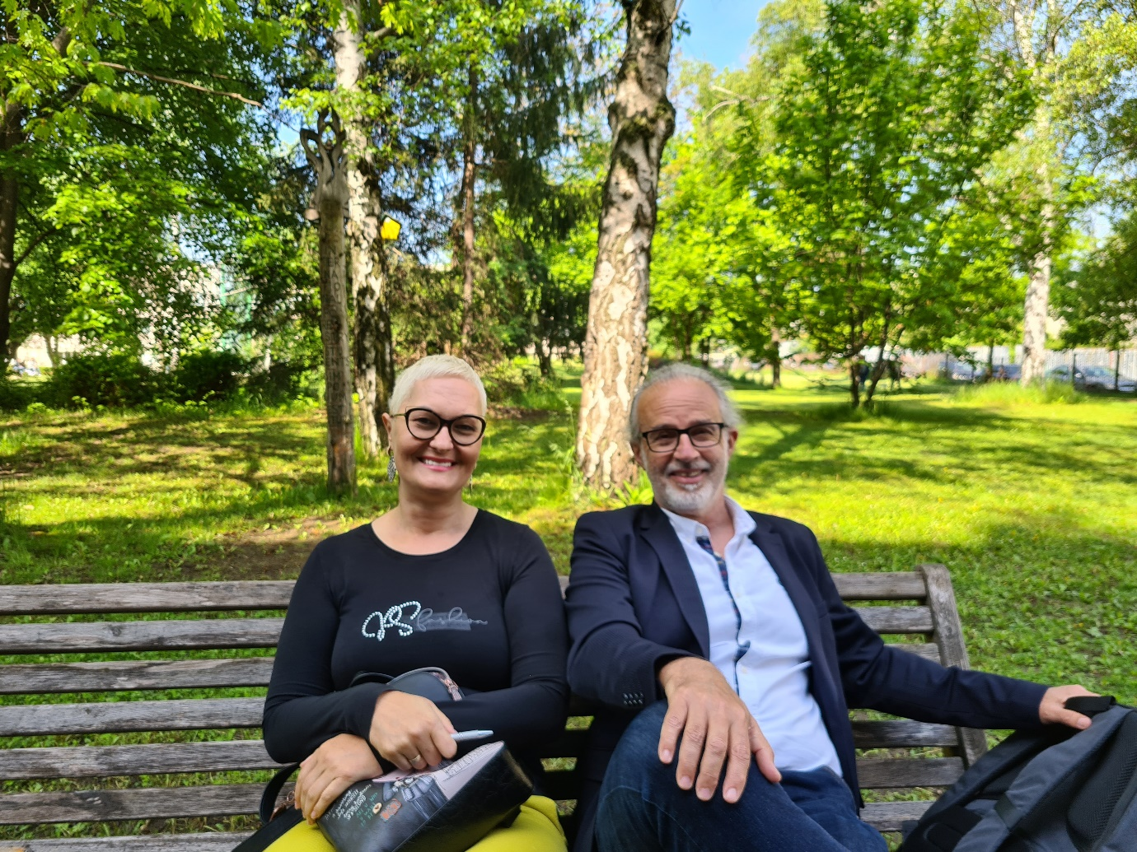
Project number: 598403-EPP-1-2018-1-RS-EPPKA2-CBHE-JP “This project has been funded with support from the European Commission. This publication reflects the view only of the author, and the Commission cannot be held responsible for any use which may be made of the information contained therein”.

In Niš, 5th June 2022.

