PROJECT INFO

Project title | Soil Erosion and Torrential Flood Prevention: Curriculum  Development at the Universities of Western Balkan Countries
Project acronym | SETOF
Project reference number | 598403-EPP-1-2018-1-RS-EPPKA2-CBHE-JP (2018-2579/001-  001)
Coordinator | University of Belgrade
Project start date | November 15, 2018
Project duration | 36 months

DOCUMENT CONTROL SHEET

Ref. No and Title of Activity
Title of Deliverable: | Minutes of the trainings in local communities in the  Federation of Bosnia and Hercegovina
Institutions: | University of Sarajevo
Author/s of the deliverable | Emira Hukić, Muhamed Bajrić
Status of the document: | draft

Summary
This document reports the Trainings in local communities in the Federation of Bosnia and Hercegovina under the Erasmus+ Capacity Building in the Field of Higher Education project “Soil Erosion and Torrential Flood Prevention: Curriculum Development at the Universities of Western Balkan Countries” (SETOF) held in building of Municipality of Zenica in Zenica September 17th, 2021, and organized by University of Sarajevo Faculty of Forestry, Bosnia and Herzegovina.

List of attendees
Twenty-two participants participated at the training. Trainers came from two partner institutions: University of Sarajevo Faculty of Forestry from Bosnia and Herzegovina, and University of Belgrade Faculty of Forestry in Serbia. Trainees came from twelve different municipalities and two cantons from Federation of Bosnia and Herzegovina. In total 17 trainees participated at training held September 17th, 2021, in Municipality of Zenica. This location was chosen because organizers were triggering local stakeholders which were most affected by soil torrential floods, landslides and erosion. The list of attendees is present below and the official agenda of the training is attached to this document. The number of trainees was limited due to COVID-19 pandemic.

According to the Agenda meeting started at 11:00 AM with the registration of the participants.
Coordinator prof. dr Muhamed Bajrić welcomed the participants.
Each participant was evidenced by organizers (Attendance list-see below).
First presentation was given by Project Coordinator Nada Dragović (UB) which was the introductory presentation about the project and joint MSc study program. After which prof. dr Ratko Ristić (UB) and prof. dr Muhamed Bajrić (UNSA) gave training about risks and preventive measures which can be implemented in field.
The training ended at 14:00 PM after the discussion with participants.

Conclusions
The conclusion is that the Trainings in local communities in the Federation of Bosnia and Hercegovina the SETOF project was successfully realized.

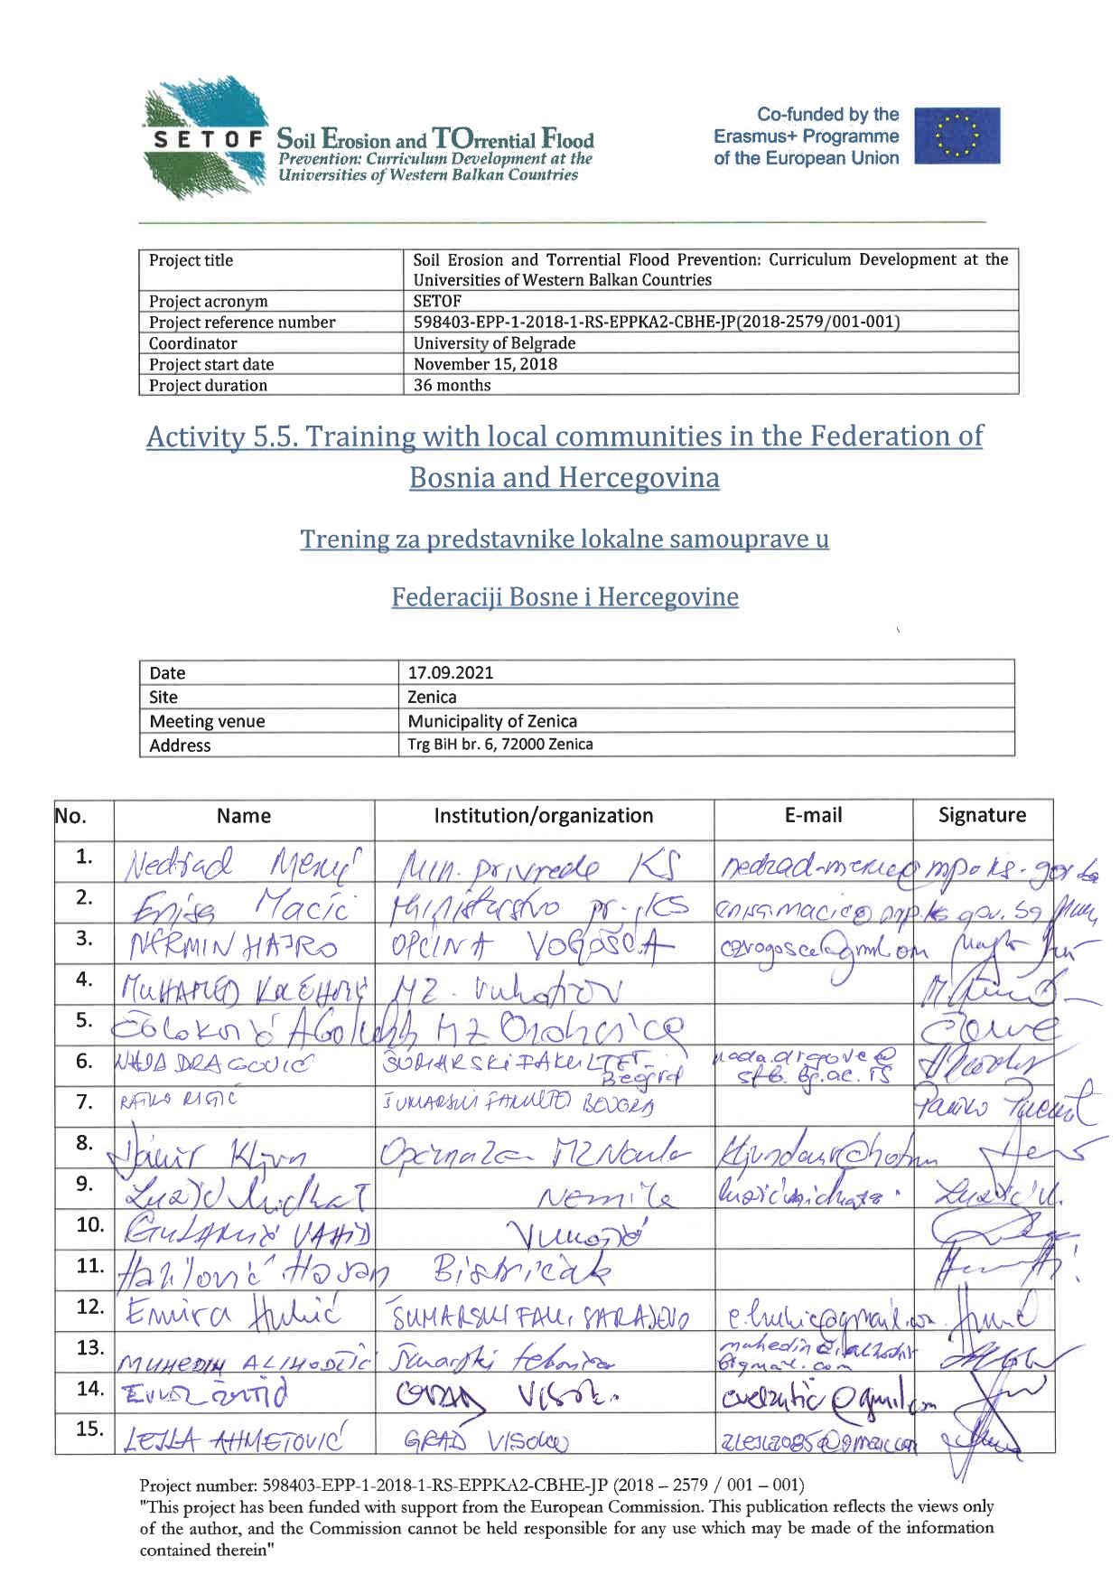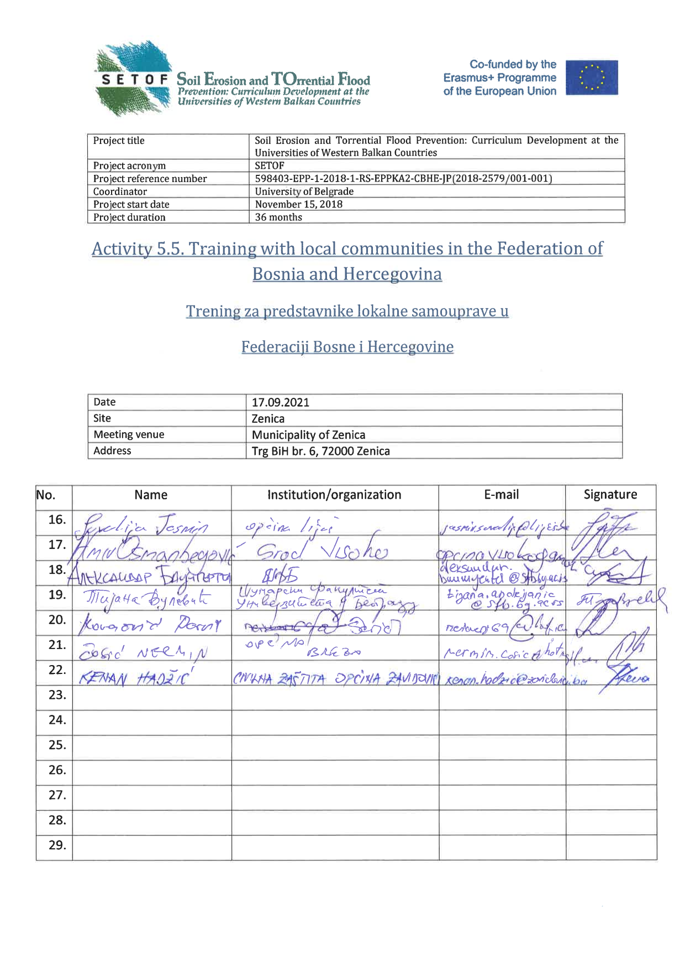

In Sarajevo, 20th September 2021
Project number: 598403-EPP-1-2018-1-RS-EPPKA2-CBHE-JP
“This project has been funded with support from the European Commission. This publication reflects the view only of the author, and the Commission cannot be held responsible for any use which may be made of the information contained therein”.

