PROJECT INFO
Project title | Soil Erosion and Torrential Flood Prevention: Curriculum Development at the Universities of Western Balkan Countries
Project acronym | SETOF
Project reference number | 598403-EPP-1-2018-1-RS-EPPKA2-CBHE-JP  (2018-2579/001-001)
Coordinator | University of Belgrade
Project start date | November 15, 2018
Project duration | 36 months

DOCUMENT CONTROL SHEET
Ref. No and Title of Activity | WP5 Dissemination of project results
Title of Deliverable: | Minutes of the Training of employees in local communities in the field of soil erosion and torrential flood prevention
Institutions: | University of Belgrade
Author/s of the deliverable | Tijana Vulević, Aleksandar Baumgertel,
Status of the document: | final

Summary
This document reports the Training of employees in local communities in the field of soil erosion and torrential flood prevention of the Erasmus+ Capacity Building in the Field of Higher Education project “Soil Erosion and Torrential Flood Prevention: Curriculum Development at the Universities of Western Balkan Countries” (SETOF) held in Valjevo, Serbia on February 25th, 2022. The moderator of the event was Natalija Momirović from the Institute of Forestry, Belgrade.

List of attendees
Twenty nine participants was present at the Training of employees in local communities in the field of soil erosion and torrential flood prevention. The list of th participats - project members from 3 partner institutions (University of Belgrade – Faculty of Forestry, University of Novi Sad – Faculty of Agriculture and Institute of Forestry) is presented in the table below. The other participants were employees in the municipality.
No | Name of the participant | Institution/Organization
 | Atila Bezdan | University of Novi Sad, Serbia
 | Radovan Savić | University of Novi Sad, Serbia
 | Boško Blagojević | University of Novi Sad, Serbia
 | Nada Dragović | University of Belgrade, Serbia
 | Tijana Vulević | University of Belgrade, Serbia
 | Aleksandar Baumgertel | University of Belgrade, Serbia
 | Katarina Lazarević | University of Belgrade, Serbia
 | Natalija Momirović | Institute of Forestry, Belgrade
 | Tomislav Stefanović | Institute of Forestry, Belgrade
 | Sonja Braunović | Institute of Forestry, Belgrade

Research Assistant Natalija Momirovic opened the meeting. The major of the local community Mionica, Boban Janković welcome participants. Prof. Nada Dragović coordinator of the SETOF project, gave inside of the joint master program.
Assitant Professor Tijana Vulević presented the “Training in local community in the area of soil erosion protection and preventon from torrential floods”.
Associate Professor, Boško Blagojević presented “Institutional organization of flood defense”.
Dr Tomislav Stefanovic presented the “Role of local municipality in soil erosion and torrential flood risk management”.

Conclusions
The conclusion is that Training of employees in local communities in the field of soil erosion and torrential flood prevention held on February 25, 2022 in Valjevo was successfully realized. All material from the meeting will be sent to the project participants.

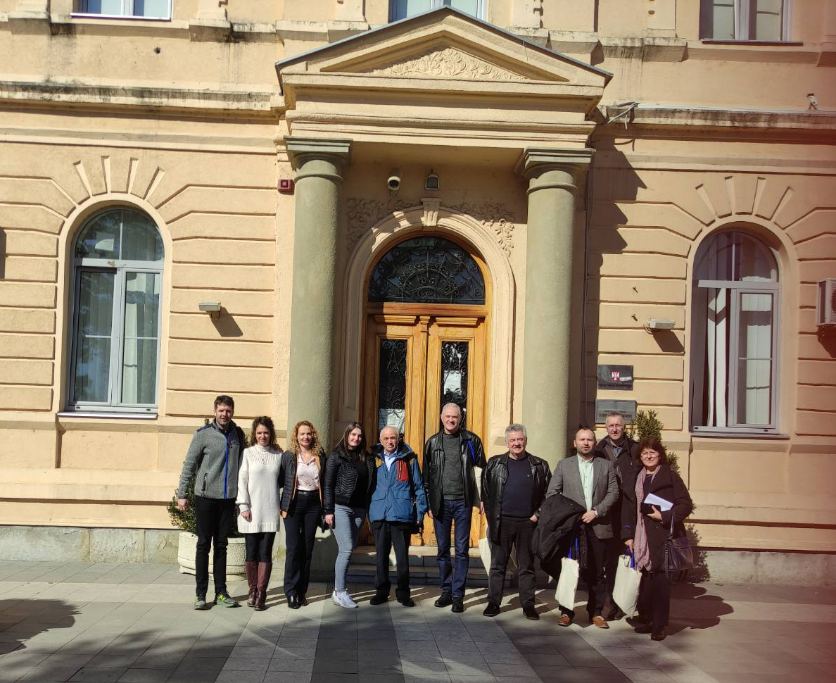

Project number: 598403-EPP-1-2018-1-RS-EPPKA2-CBHE-JP
“This project has been funded with support from the European Commission. This publication reflects the view only of the author, and the Commission cannot be held responsible for any use which may be made of the information contained therein”.

In Belgrade, 01 March 2022

