PROJECT INFO

Project title | Soil Erosion and Torrential Flood Prevention: Curriculum  Development at the Universities of Western Balkan Countries
Project acronym | SETOF
Project reference number | 598403-EPP-1-2018-1-RS-EPPKA2-CBHE-JP (2018-2579/001-  001)
Coordinator | University of Belgrade
Project start date | November 15, 2018
Project duration | 36 months

DOCUMENT CONTROL SHEET

Ref. No and Title of Activity
Title of Deliverable: | Minutes of the trainings in local communities in the  Republic of Srpska
Institutions: | University of Banja Luka
Author/s of the deliverable | Marijana Kapovic Solomun, Branislav Cvjetkovic, Vanja Danicic
Status of the document: | draft

Summary
This document reports the Minutes of the promotion trainings with representatives of local communities of the Bosnia and Herzegovina within a SETOF project of the Erasmus+ Capacity Building in the Field of Higher Education project “Soil Erosion and Torrential Flood Prevention: Curriculum Development at the Universities of Western Balkan Countries” (SETOF) held in Prijedor, BiH on December 7th, 2021.

List of attendees
Eight participants from 3 institutions in Prijedor participated to this training. The list of attendees is present below.
No. | Name of participant | Institution
1 | Branislav Cvjetkovic | University of Banja Luka Faculty of Forestry
2 | Ilija Cigoja | University of Banja Luka Faculty of Forestry
3 | Silvana Jojic | Prijedor City
4 | Bosko Stojancic | Prijedor City
5 | Radjenovic Sasa | SG Prijedor
6 | Danijel Sidjak | NP Kozara
7 | Igor Suvajac | Prijedor City
8 | Lazar Gajic | Prijedor City

Assistant professor Branislav Cvjetkovic and Ilija Čigoja teaching assistant the Faculty of Forestry University of Banja Luka opened meeting and welcome participants. The meeting covered several topics: joint master study program, soil erosion, and prevention of torrential floods in Bosnia and Herzegovina with particular accent on the role of local stakeholders in prevention of floods on the local level (WP5 Dissemination of project results, Activity 5.5. promotion trainings with engineers in enterprises).

Assistant professor Branislav Cvjetkovic gave the overview of the SETOF project objectives, content (work packages), main deliverables, and information regarding the joint master study program including the list of obligatory and elective subjects and teachers from two or more universities engaged in the development of the syllabuses and conducting teaching activities.

Assistant professor Branislav Cvjetkovic and Ilija Čigoja teaching assistant presented role of local communities in torrential flood risk management and soil erosion protection. History of flood events in BiH and Serbia has been discussed with particular focus on experience of other local communities in terms on organization and management of flood risk.
After presentations, discussion is developed with participants. Participants were very interested to know more on financial construction of presented organization of local communities aimed to oprevent and mitigate floods. Many problems are raised and discussed.

Conclusions
The conclusion is that Promotion trainings with local communities of BiH was successfully realized. All material from the meeting will be sent to the project participants.

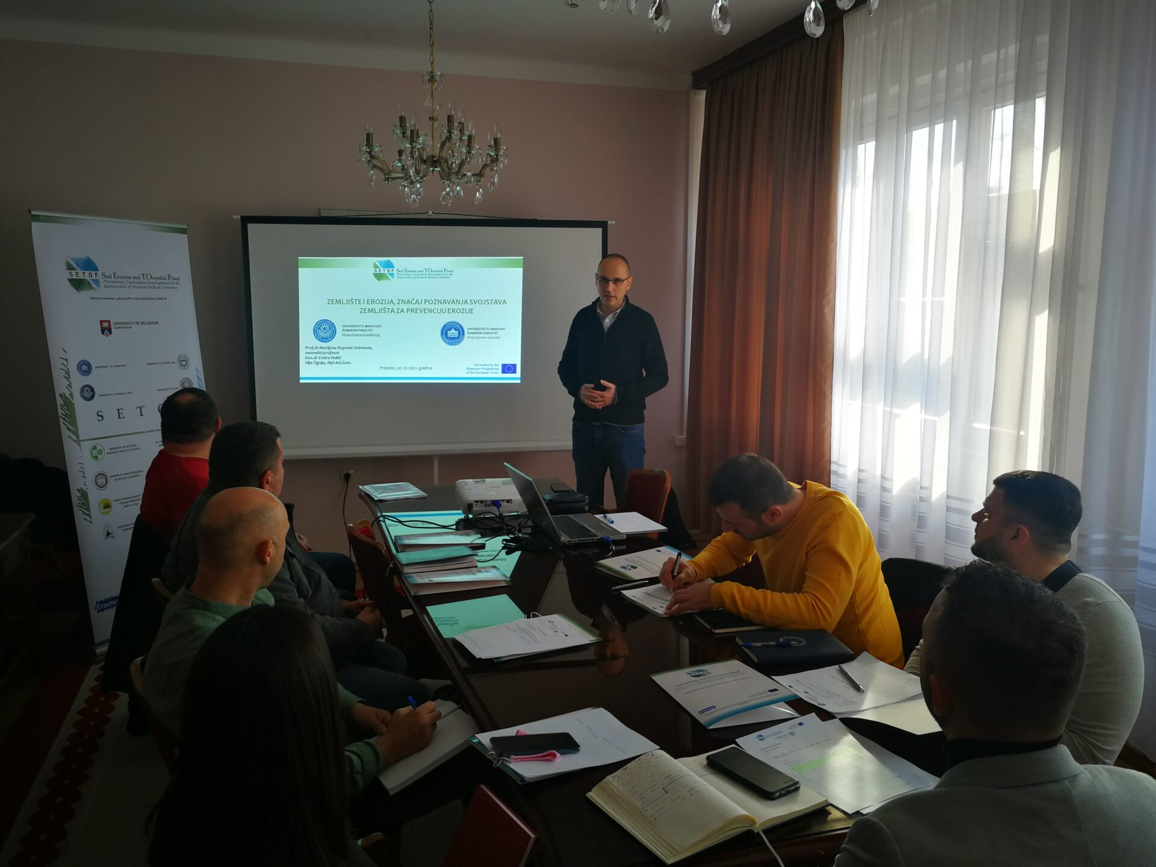

https://www.sf.unibl.org/2021/12/09/odrzana-radionica-u-prijedoru-na-temu-zastita-zemljista-od-erozije-i-prevencija-od-bujicnih-poplava/
Project number: 598403-EPP-1-2018-1-RS-EPPKA2-CBHE-JP
“This project has been funded with support from the European Commission. This publication reflects the view only of the author, and the Commission cannot be held responsible for any use which may be made of the information contained therein”.

