PROJECT INFO

Project title | Soil Erosion and Torrential Flood Prevention: Curriculum  Development at the Universities of Western Balkan Countries
Project acronym | SETOF
Project reference number | 598403-EPP-1-2018-1-RS-EPPKA2-CBHE-JP (2018-2579/001-  001)
Coordinator | University of Belgrade
Project start date | November 15, 2018
Project duration | 36 months

DOCUMENT CONTROL SHEET

Ref. No and Title of Activity
Title of Deliverable: | Minutes of the Trainings in local communities in the Republic of Srpska
Institutions: | University of Banja Luka
Author/s of the deliverable | Tijana Vulević, Aleksandar Baumgertel
Status of the document: | draft

Summary
This document reports the Trainings in local communities in the Republic of Srpska under the Erasmus+ Capacity Building in the Field of Higher Education project “Soil Erosion and Torrential Flood Prevention: Curriculum Development at the Universities of Western Balkan Countries” (SETOF) held in Gradiška, on May 28th 2021 and organized by University of Banja Luka Faculty of Forestry, Bosnia and Herzegovina and municipality of Gradiška.

List of attendees
Twenty-six participants participated at the training. Trainers came from two partner institutions: University of Banja Luka Faculty of Forestry from Bosnia and Herzegovina and University of Belgrade Faculty of Forestry from the Republic of Serbia.
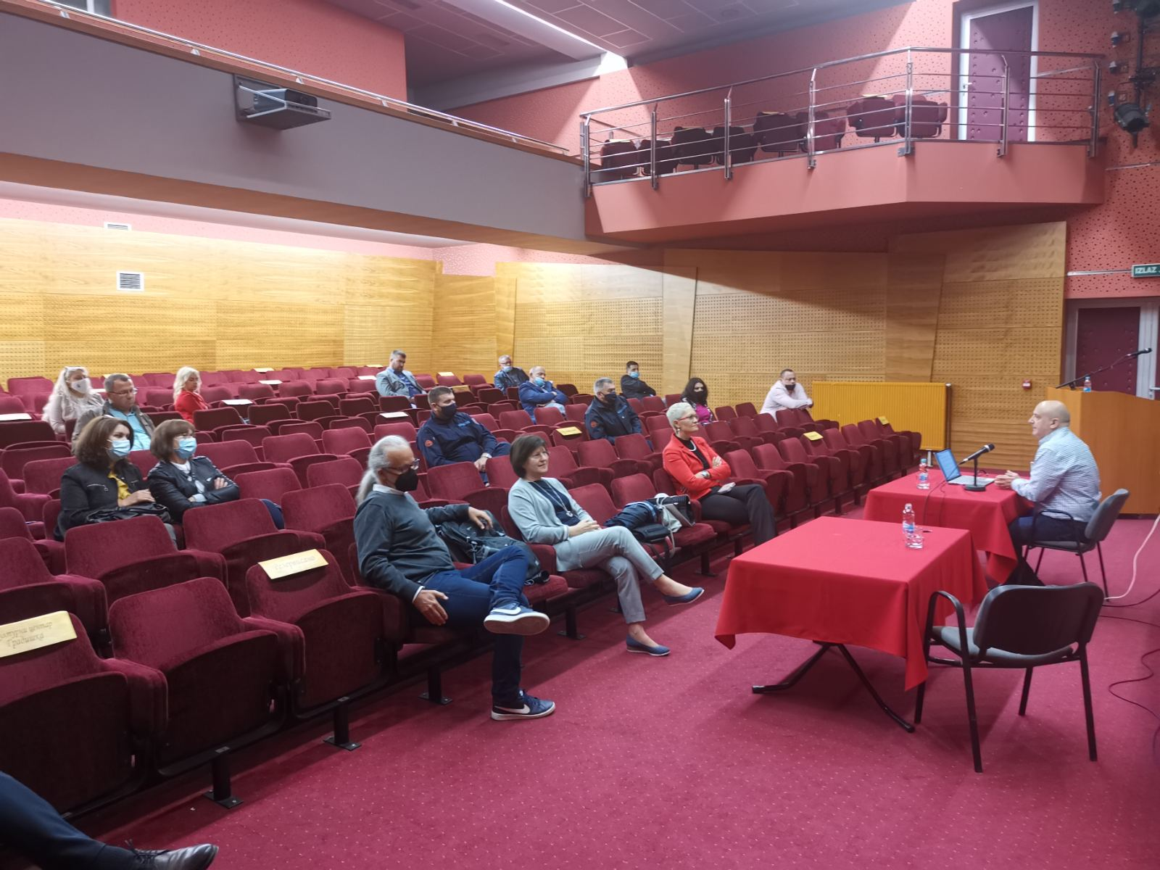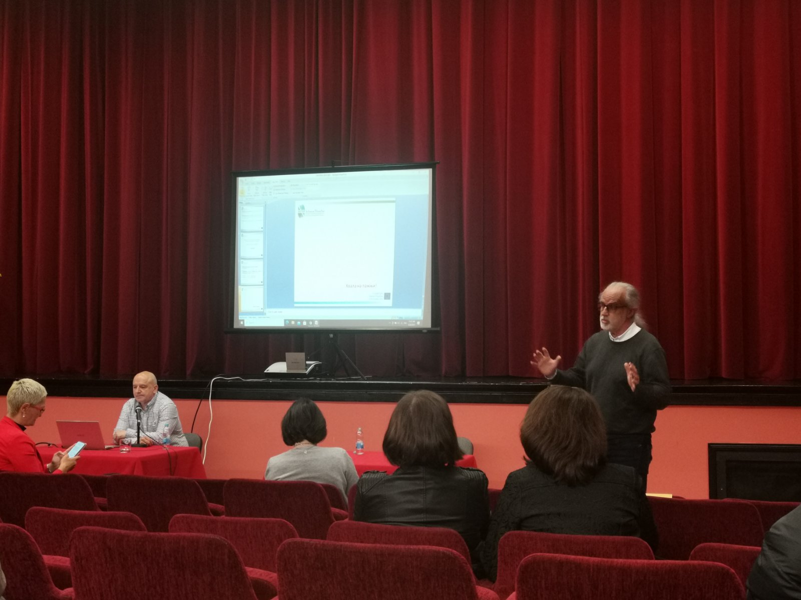
The presentations about new joint master program and the role of local communities in risk management were presented by Project Coordinator dr Nada Dragović and dean of the Faculty of Forestry University of Belgrade dr Ratko Ristić. Participants had a chance to get useful information about this topic based on the experience from a municipalities from the Republic of Serbia.

The training ended at 14:00 PM after discussion and questions.

Conclusions
The conclusion is that the Trainings in local communities in the Republic of Srpska the SETOF project was successfully realized.

Project number: 598403-EPP-1-2018-1-RS-EPPKA2-CBHE-JP
“This project has been funded with support from the European Commission. This publication reflects the view only of the author, and the Commission cannot be held responsible for any use which may be made of the information contained therein”.

In Gradiška, 28. May 2021

