PROJECT INFO

Project title | Soil Erosion and Torrential Flood Prevention: Curriculum  Development at the Universities of Western Balkan Countries
Project acronym | SETOF
Project reference number | 598403-EPP-1-2018-1-RS-EPPKA2-CBHE-JP (2018-2579/001-  001)
Coordinator | University of Belgrade
Project start date | November 15, 2018
Project duration | 36 months

DOCUMENT CONTROL SHEET

Ref. No and Title of Activity
Title of Deliverable: | Minutes of the Training with engineers in the Federation of Bosnia and Herzegovina
Institutions: | University of Sarajevo
Author/s of the deliverable | Emira Hukić, Muhamed Bajrić
Status of the document: | draft

Summary
This document reports the Training with engineers in the Federation of Bosnia and Herzegovina under the Erasmus+ Capacity Building in the Field of Higher Education project “Soil Erosion and Torrential Flood Prevention: Curriculum Development at the Universities of Western Balkan Countries” (SETOF) held in Sarajevo September 16th 2021 and organized by University of Sarajevo Faculty of Forestry, Bosnia and Herzegovina.

List of attendees
Twenty-three participants participated at the training. Trainers came from three partner institutions: University of Sarajevo Faculty of Forestry, University of Banja Luka Faculty of Forestry from Bosnia and Herzegovina, and University of Belgrade Faculty of Forestry in Serbia. Trainees came from eight organizations and forest enterprises form Federation of Bosnia and Herzegovina. In total 15 trainees participated at training held September 16th 2021 at the Faculty of Forestry in Sarajevo. The list of attendees is present below and the official agenda of the training is attached to this document. The number of trainees was limited due to COVID-19 pandemic.

According to the Agenda meeting started at 11,00 AM with the registration of the participants.
Vice-rector prof. dr. Mirza Dautbašić and coordinator welcomed the participants.
Each participant was evidenced by organizers (Attendance list-see below).
First presentation was given by Project Coordinator Nada Dragović (UB) which was the introductory presentation about the project and joint MSc study program. After which doc. dr Branislav Cvjetković (UBL) gave presentation about silvicultural measures for forest site rehabilitation and afforestation. The presentation was followed by prof. dr Ćemal Višnić (UNSA) who presented silvicultural practices which prevent soil erosion. After short coffee break doc. dr Emira Hukić (UNSA) was talking about soil properties and how to detect in field potentially susceptible soils to erosion. Two last lectures were about soil torrential floods and erosion risks and control given by prof. dr Ratko Ristić (UB) and prof. dr Muhamed Bajrić (UNSA).
The training ended at 15:00 PM after short discussion and participants had chance to informal conversations during lunch provided by organizers at the Faculty of Forestry.

Conclusions
The conclusion is that the Training with engineers in the Federation of Bosnia and Herzegovina under the SETOF project was successfully realized.

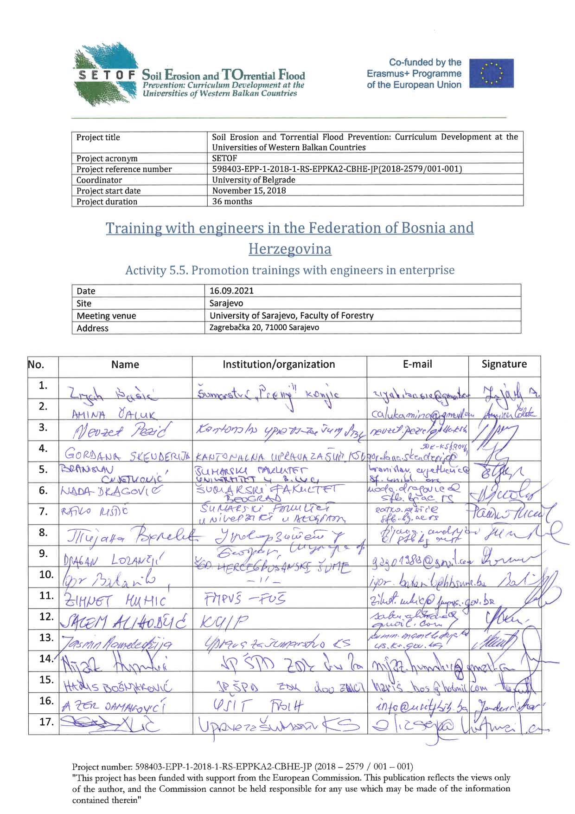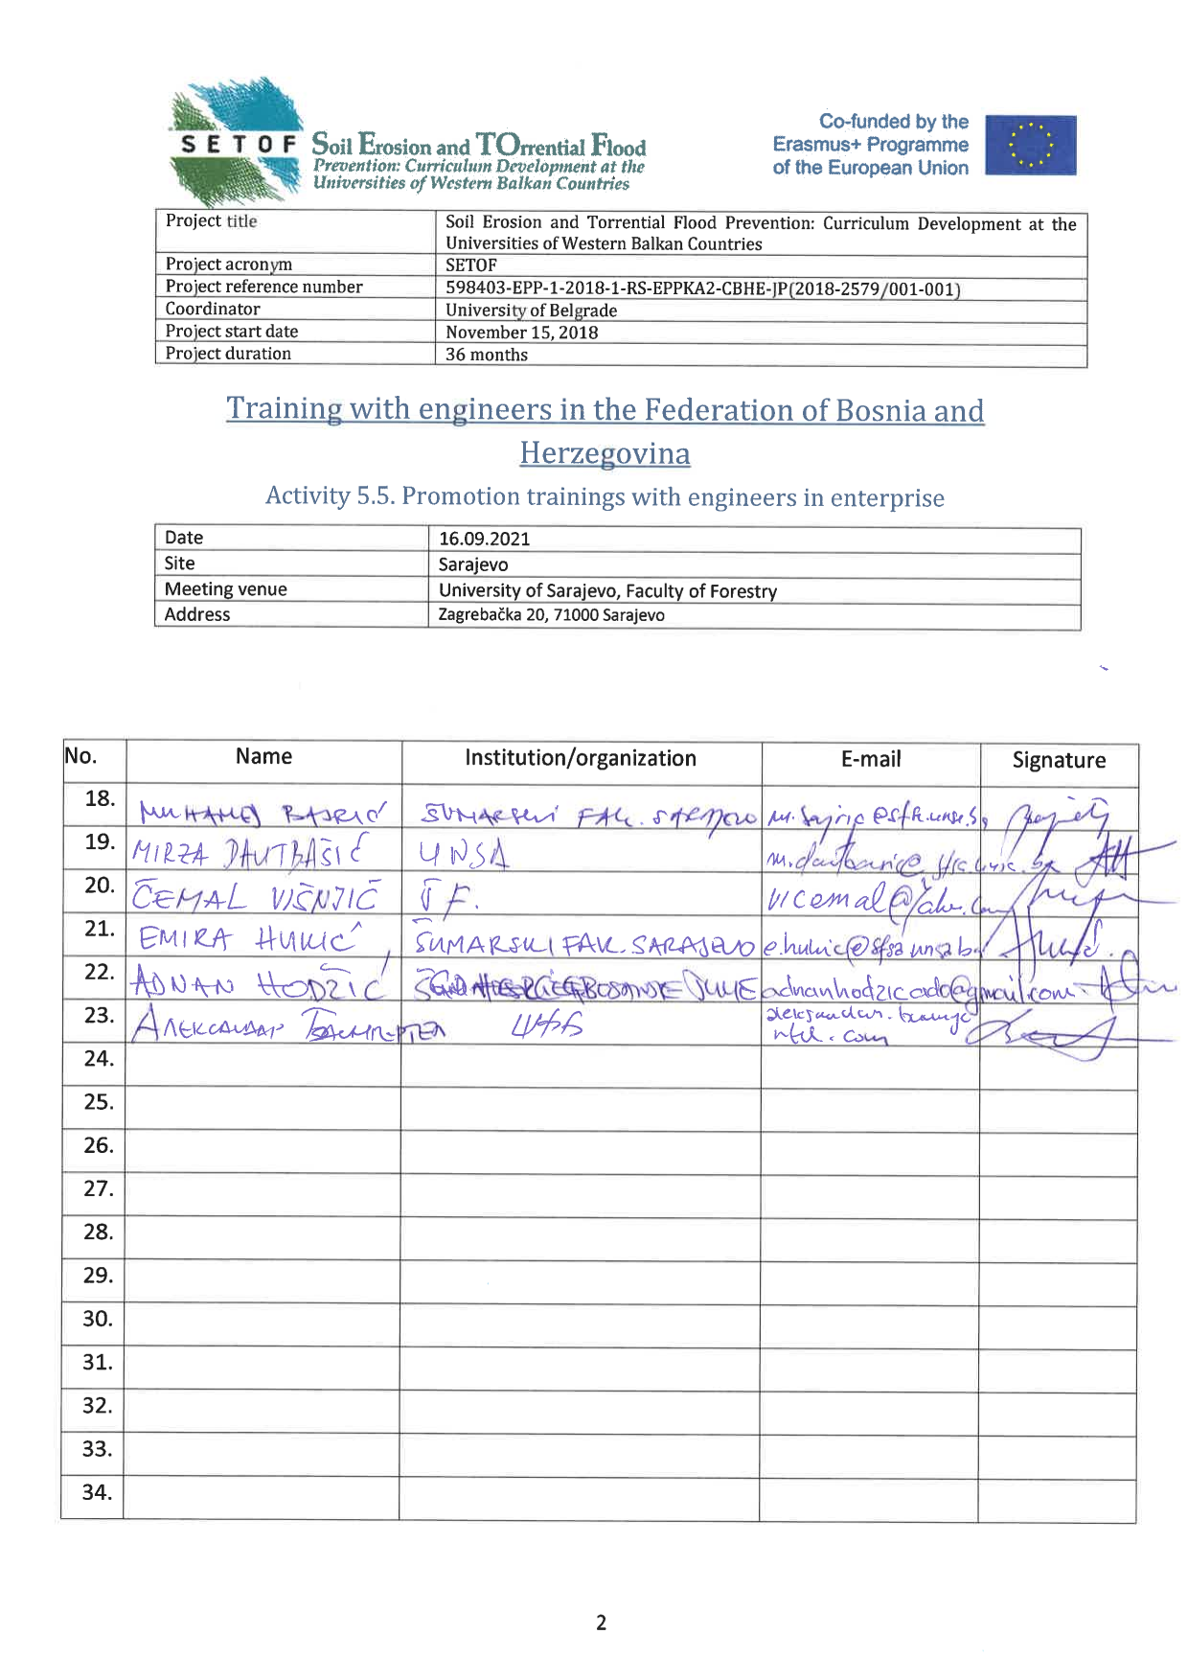
Project number: 598403-EPP-1-2018-1-RS-EPPKA2-CBHE-JP
“This project has been funded with support from the European Commission. This publication reflects the view only of the author, and the Commission cannot be held responsible for any use which may be made of the information contained therein”.

In Sarajevo, 20 September 2021

