PROJECT INFO

Project title | Soil Erosion and Torrential Flood Prevention: Curriculum  Development at the Universities of Western Balkan Countries
Project acronym | SETOF
Project reference number | 598403-EPP-1-2018-1-RS-EPPKA2-CBHE-JP (2018-2579/001-  001)
Coordinator | University of Belgrade
Project start date | November 15, 2018
Project duration | 36 months

DOCUMENT CONTROL SHEET

Ref. No and Title of Activity
Title of Deliverable: | Minutes of the Trainings with engineers in the Republic of Srpska
Institutions: | University of Banja Luka
Author/s of the deliverable | Tijana Vulević, Aleksandar Baumgertel
Status of the document: | draft

Summary
This document reports the Trainings with engineers in the Republic of Srpska under the Erasmus+ Capacity Building in the Field of Higher Education project “Soil Erosion and Torrential Flood Prevention: Curriculum Development at the Universities of Western Balkan Countries” (SETOF) held in Banja Luka, May 27th 2021 and organized by University of Banja Luka Faculty of Forestry, Bosnia and Herzegovina.

List of attendees
Thirty-four participants participated at the training. Trainers came from three partner institutions: University of Banja Luka Faculty of Forestry from Bosnia and Herzegovina, University of Belgrade Faculty of Forestry from the Republic of Serbia and University of Sarajevo Faculty of Forestry from Bosnia and Herzegovina. The number of trainees was limited due to COVID-19 pandemic.
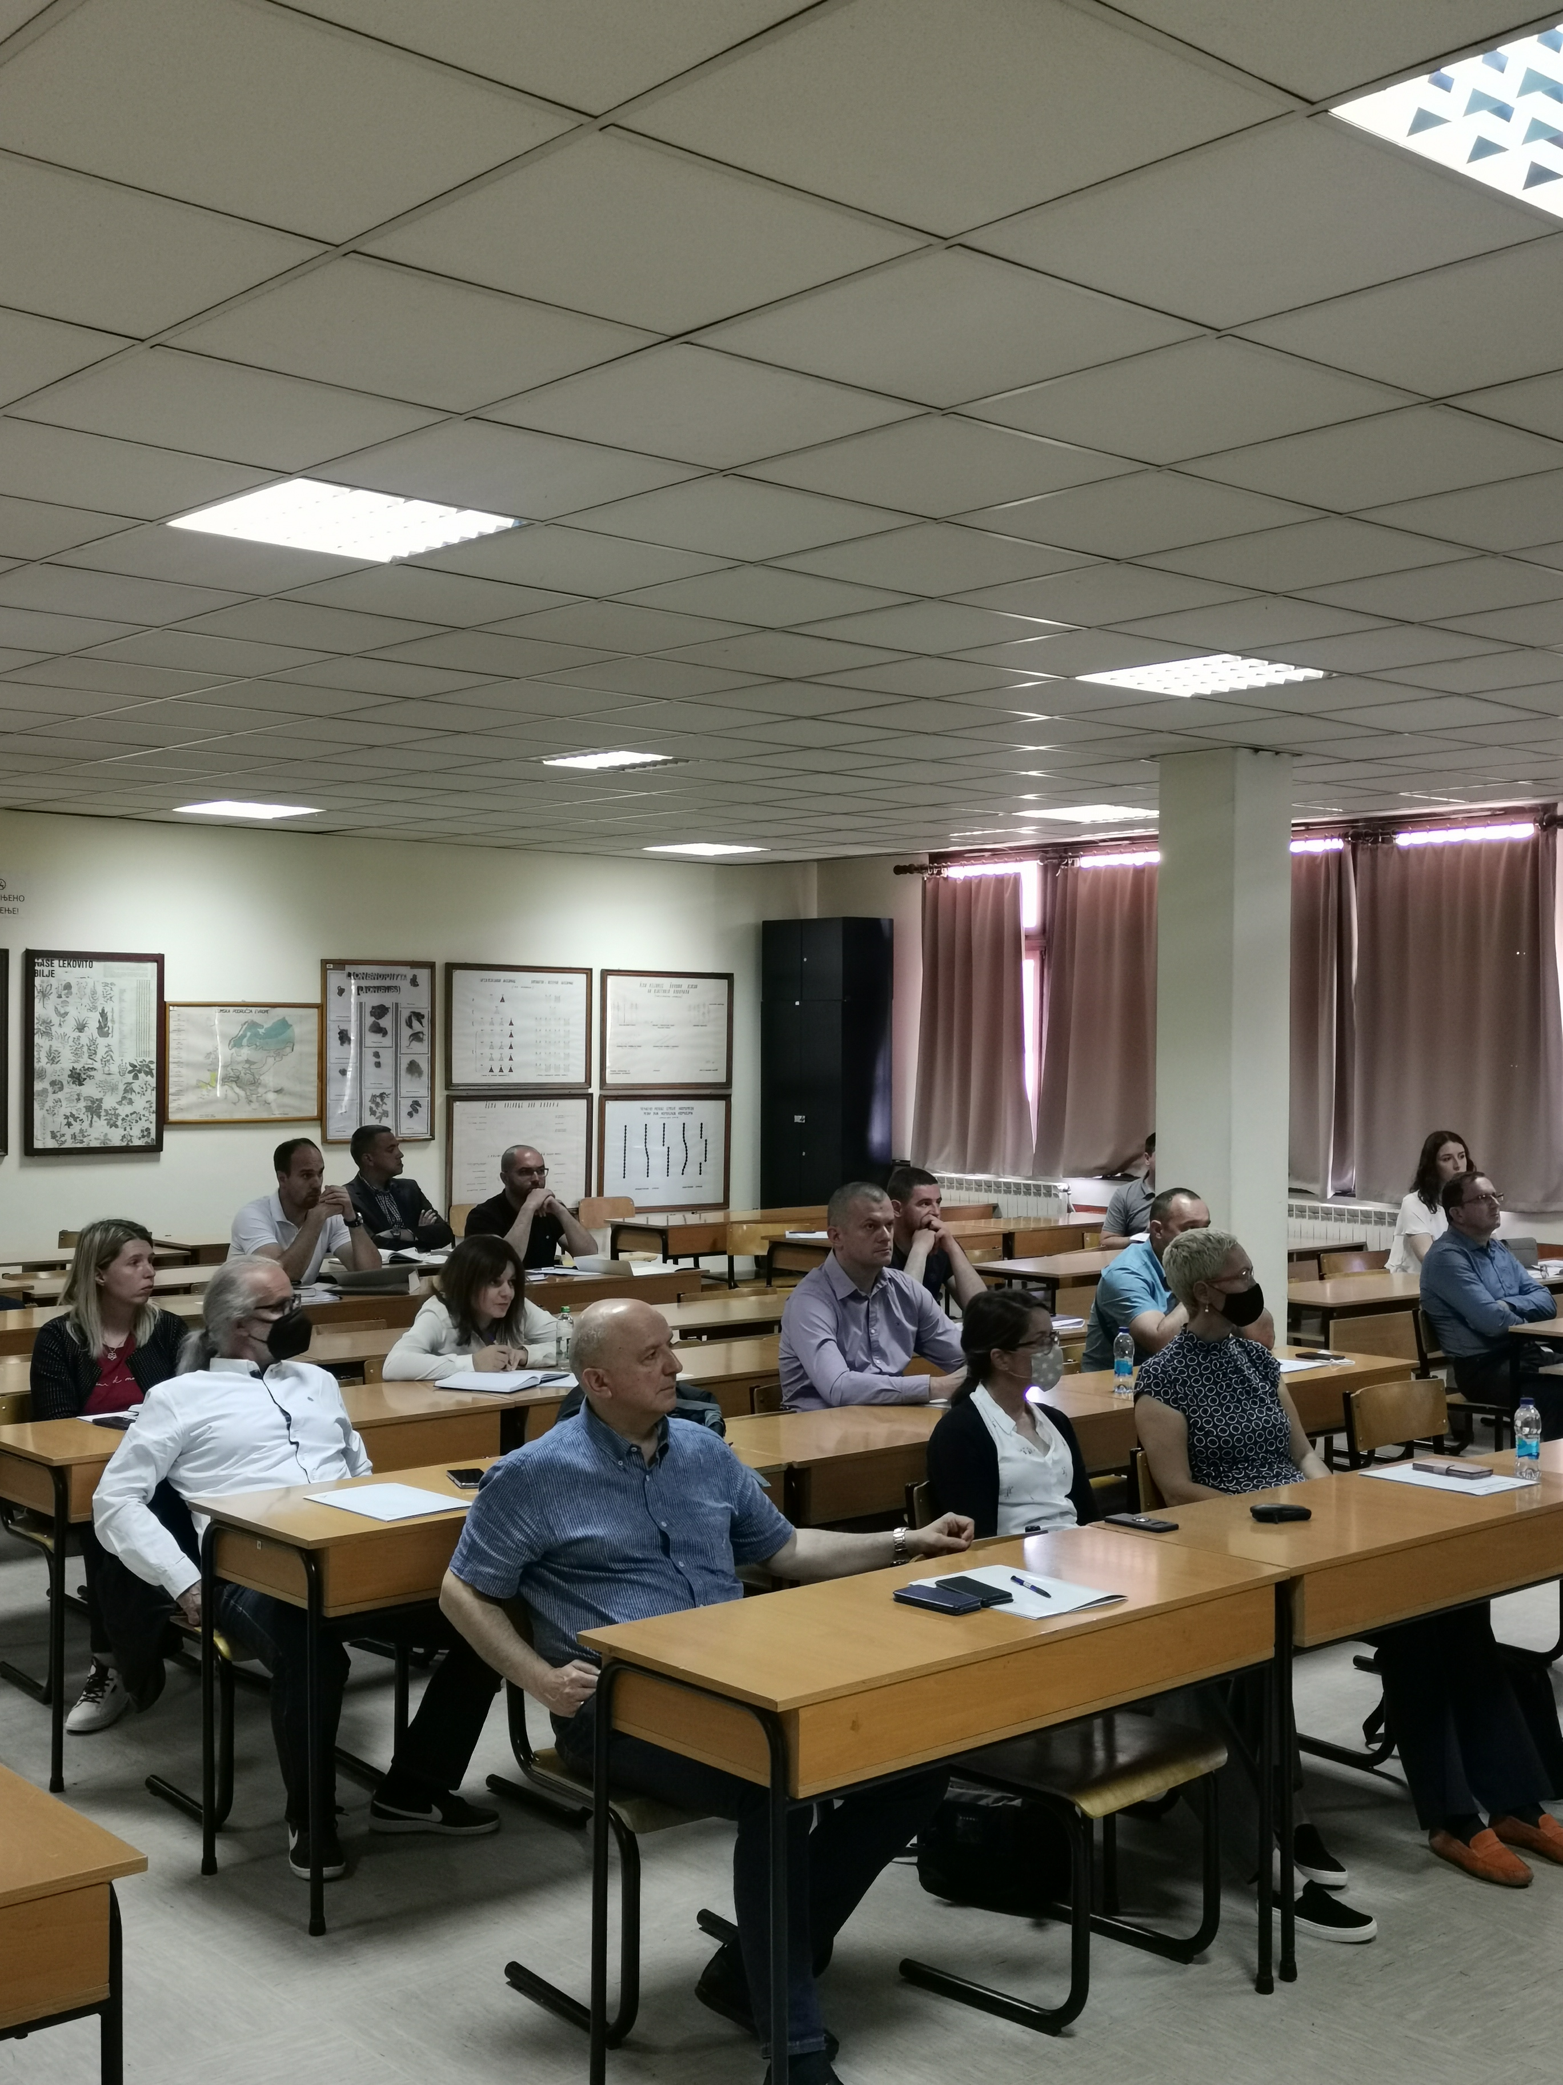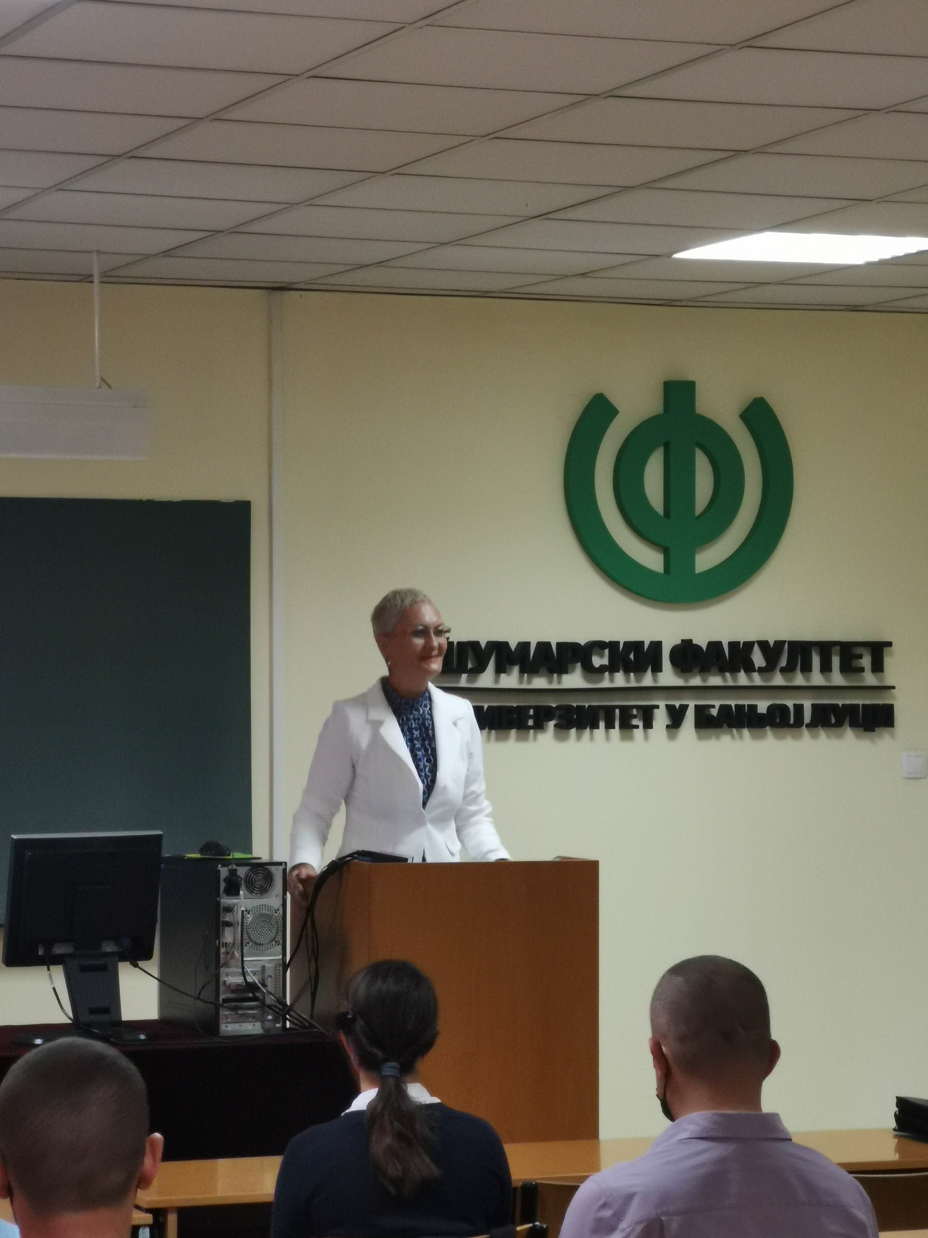

According to the Agenda meeting started at 11,.00 AM with the registration of the participants.
The presentations were presented by dr Branislav Cvjetković, dr Muhamed Bajrić, dr Emira Hukić and dr. Nada Dragović. Presentation covers topics about biological recultivation and prevention of erosion processes, Forest management for prevention of floods and soil erosion as well as soil properties and soil erosion. Also, the Project Coordination (dr Nada Dragović) presented new joint master program study and gave all necessary information about enrolment process as well as potential benefits for new students.

The training ended at 15:00 PM after discussion and questions.

Conclusions
The conclusion is that the Trainings with engineers in the Republic of Srpska the SETOF project was successfully realized.

Project number: 598403-EPP-1-2018-1-RS-EPPKA2-CBHE-JP
“This project has been funded with support from the European Commission. This publication reflects the view only of the author, and the Commission cannot be held responsible for any use which may be made of the information contained therein”.

In Banja Luka, 27. May 2021

