PROJECT INFO
Project title | Soil Erosion and Torrential Flood Prevention: Curriculum Development at the Universities of Western Balkan Countries
Project acronym | SETOF
Project reference number | 598403-EPP-1-2018-1-RS-EPPKA2-CBHE-JP  (2018-2579/001-001)
Coordinator | University of Belgrade
Project start date | November 15, 2018
Project duration | 36 months

DOCUMENT CONTROL SHEET
Ref. No and Title of Activity | WP5 Dissemination & Exploitation
Title of Deliverable | Minutes of the promotion trainings with engineers in enterprise Vodoprivredno društvo „Dunav“ ad Bačka Palanka
Institutions | University of Novi Sad
Author/s of the deliverable | Atila Bezdan, Milica Vranešević, Dragana Krajinović
Status of the document | final

Summary
This document reports the Minutes of the promotion trainings with engineers in enterprise Vodoprivredno društvo „Dunav“ ad Bačka Palanka within a SETOF project of the Erasmus+ Capacity Building in the Field of Higher Education project “Soil Erosion and Torrential Flood Prevention: Curriculum Development at the Universities of Western Balkan Countries” (SETOF) held in Bačka Palanka, Serbia on October 29th , 2021.

List of attendees
Fifteen participants from 4 institutions participated at the Minutes of the promotion trainings with engineers in enterprise Vodoprivredno društvo „Dunav“ad Bačka Palanka. The list of attendees is present below.
No. | Name of the participant | Institution/Organization
1. | Vuletić Aleksandar | Vodoprivredno društvo „Dunav“ ad Bačka Palanka
2. | Rađenović Milan | Vodoprivredno društvo „Dunav“ ad Bačka Palanka
3. | Bugorović Ivana | Vodoprivredno društvo „Dunav“ ad Bačka Palanka
4. | Lažetić Milanka | Vodoprivredno društvo „Dunav“ ad Bačka Palanka
5. | Čoja Ferid | Vodoprivredno društvo „Dunav“ ad Bačka Palanka
6. | Šušnica Branko | Vodoprivredno društvo „Dunav“ ad Bačka Palanka
7. | Radišić Goran | Vodoprivredno društvo „Dunav“ ad Bačka Palanka
8. | Keleč Nebojša | Vodoprivredno društvo „Dunav“ ad Bačka Palanka
9. | Obarnica Zorica | Vodoprivredno društvo „Dunav“ ad Bačka Palanka
10. | Čobanović Jelena | Vodoprivredno društvo „Dunav“ ad Bačka Palanka
11. | Keleč Milena | Vodoprivredno društvo „Dunav“ ad Bačka Palanka
12. | Sušnica Anđelka | Vodoprivredno društvo „Dunav“ ad Bačka Palanka
13. | Stanivuk Sretko | Vodoprivredno društvo „Dunav“ ad Bačka Palanka
14. | Momirović Natalija | Institute of Forestry
15. | Vulević Tijana | University of Belgrade, Faculty of Forestry
16. | Katarina Lazarević | University of Belgrade, Faculty of Forestry
17. | Blagojević Boško | University of Novi Sad, Faculty of Agriculture
18. | Mesić Muhamed | Vodoprivredno društvo „Dunav“ ad Bačka Palanka
19. | Savić Radovan | University of Novi Sad, Faculty of Agriculture
20. | Baumgertel Aleksandar | University of Belgrade, Faculty of Forestry
21. | Bezdan Atila | University of Novi Sad, Faculty of Agriculture
22. | Vranešević Milica | University of Novi Sad, Faculty of Agriculture

Prof. dr Atila Bezdan and Goran Radišić, director of the enterprise Vodoprivredno društvo „Dunav“ad Bačka Palanka opened the meeting and welcome participants. The meeting covered several topics: joint master study program, soil erosion, and prevention of torrential floods in Serbia, the experience of European countries in the prevention of floods, and application of remote sensing in excess water detection (WP5 Dissemination of project results, Activity 5.5. promotion trainings with engineers in enterprises). Prof. dr Atila Bezdan, doc. dr Tijana Vulević and Msc. Katarina Lazarević gave the overview of the SETOF project objectives, content (work packages), main deliverables, and information regarding the joint master study program including the list of obligatory and elective subjects and teachers from two or more universities engaged in the development of the syllabuses and conducting teaching activities. Prof. dr Radovan Savić, prof. dr Milica Vranešević and Msc. Aleksandar Baumgertel, provides some inside into soil erosion and torrential floods problem and prevention in Serbia. Prof. dr Atila Bezdan gave some overview of application of remote sensing in excess water detection. Msc. Natalija Momirović gave a history of experience of European countries in the prevention of torrential floods, including Bulgaria, Northern Macedonia, Italy, and Austria. Goran Radišić, director at the enterprises Vodoprivredno društvo „Dunav“ad Bačka Palanka, presented the enterprise activities and experience in the prevention of torrential floods. The member of the SETOF project and employed at the Vodoprivredno društvo „Dunav“ad Bačka Palanka enterprise discussed the previous works on erosion and torrential flood prevention, good and bad examples of the constructed objects, and future activities.

Conclusions
The conclusion is that Promotion trainings with engineers in enterprise Vodoprivredno društvo „Dunav“ad Bačka Palanka was successfully realized. All material from the meeting will be sent to the project participants.
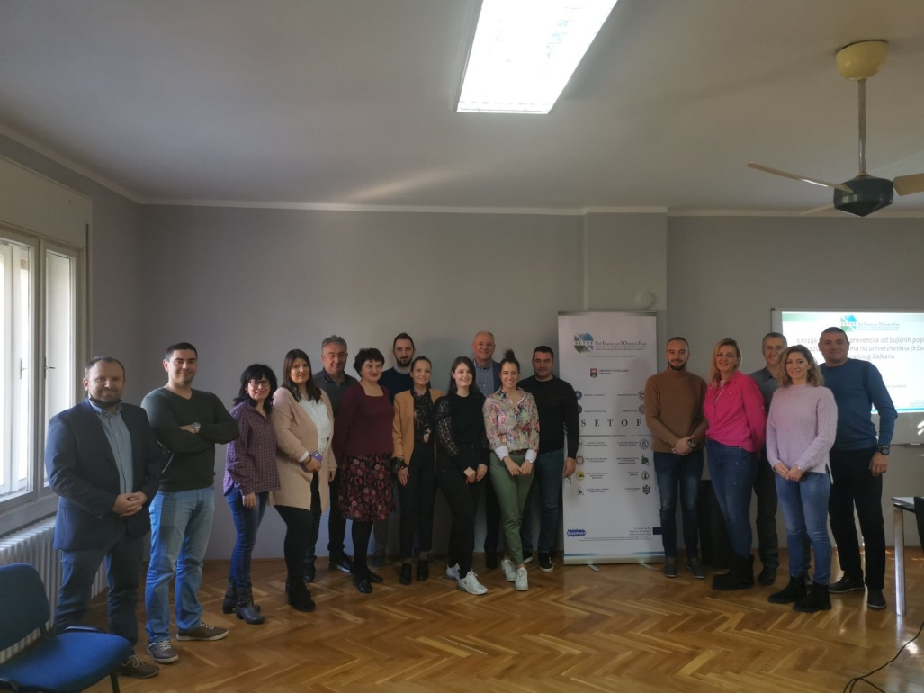
Project number: 598403-EPP-1-2018-1-RS-EPPKA2-CBHE-JP “This project has been funded with support from the European Commission. This publication reflects the view only of the author, and the Commission cannot be held responsible for any use which may be made of the information contained therein”.

In Novi Sad, 4th November 2021

